

Physical Experiment Ⅱ

Lab Report

|  |  |
| --- | --- |
| Lab Title: | The Franck-Hertz Experiment |
| Name (in Chinese): | 曹城玮 |
| UESTC ID: | 2024300901016 |
| Instructor: | 吴静 |
| Teaching Assistant: | 吴振宇 |
| Date: | 2025.9.13 |
| Score: |  |

|  |
| --- |
| **Score** |
|  |

**Abstract** (About 100 words, 3 points)

The aim of this experiment was to verify the quantization of atomic energy levels and to determine the first excitation potential of the argon atom. This was achieved by analyzing the relationship between the anode current and the accelerating voltage in a Franck-Hertz tube. The results demonstrated a distinct periodic variation in the current, confirming the principles of inelastic electron collisions. From the coordinates of the current crests, the first excitation potential of argon was calculated to be 10.87 V. This result, with a relative error of 6.3% against the accepted value of 11.6 V, provides strong quantitative evidence for the existence of discrete energy states within atoms.

|  |
| --- |
| **Score** |
|  |

**Introduction** (3 points)

At the dawn of the 20th century, classical physics faced significant challenges in explaining phenomena at the atomic scale, most notably the discrete line spectra emitted by elements. The observation that atoms only emit and absorb light at specific, characteristic frequencies suggested that their internal energy structure was not continuous as classical theories would predict. In 1913, Niels Bohr proposed a revolutionary model of the atom that incorporated the nascent concepts of quantum theory. Bohr’s model was built on a set of radical postulates: that electrons exist in stable, non-radiating orbits corresponding to discrete energy levels, and that they emit or absorb energy only when transitioning between these specific levels.

While Bohr's model successfully explained the hydrogen spectrum, it was a theoretical construct that lacked direct experimental validation. The Franck-Hertz experiment, first conducted in 1914 by James Franck and Gustav Hertz, was designed to provide this crucial evidence. Its principle is elegantly simple yet profound: to probe the internal energy structure of atoms by bombarding them with a beam of electrons of controlled kinetic energy.

The experiment investigates the different types of collisions between electrons and atoms. In an elastic collision, the electron loses a negligible amount of kinetic energy. However, if the electron's kinetic energy is equal to or greater than the energy difference between the atom's ground state and an excited state, an inelastic collision can occur. In this process, the atom absorbs a quantum of energy from the electron, causing it to jump to a higher energy level. The electron, having lost this specific amount of energy, is significantly slowed down. By measuring the electric current of electrons that pass through a gas-filled tube, a series of sharp drops in current can be observed. Each drop corresponds to the energy at which electrons can cause the atoms to transition to their first excited state.

This experiment, therefore, serves as a direct and compelling demonstration of the quantization of atomic energy. The objective of this lab is to replicate this landmark experiment using argon gas, to observe the periodic variation in current as the accelerating voltage is increased, and to determine the first excitation potential of the argon atom from the collected data.

|  |
| --- |
| **Score** |
|  |

**Experimental Procedure** (State main steps in order of performance, 3 points)

**1.Apparatus Setup and Preheating**

(1)The wires for the apparatus were connected according to the schematic diagram, and all connections were thoroughly checked before powering on the unit.

(2)The apparatus was allowed to pre-heat for approximately five minutes before applying voltages to the Franck-Hertz tube.

**2.Parameter Configuration**

(1)The recommended values for the filament voltage (V₁), accelerating voltage (V₂), and retarding voltage (V₃) were set using the knobs on the control panel.

**3.Manual Data Collection**

(1)The relationship between the anode current (Iᴀ) and the main accelerating voltage (V₄) was measured in manual mode.

(2)Using the control panel, the accelerating voltage V₄ was increased systematically in 1 V intervals.

(3)At each voltage step, the corresponding current was read directly from the instrument's integrated picoammeter, and the results were manually recorded in Data Table

|  |
| --- |
| **Score** |
|  |

**Results** (Data tables and figures, 2 points)

*V*1*= 2.0* ; *V*2*= 2* ; *V*3*= 8* ;

(The unit of the current in the following table is 0.1nA )

|  |  |  |  |  |  |  |  |  |  |  |
| --- | --- | --- | --- | --- | --- | --- | --- | --- | --- | --- |
|  | 0.0 | 1.0 | 2.0 | 3.0 | 4.0 | 5.0 | 6.0 | 7.0 | 8.0 | 9.0 |
| 0 | 0 | 0 | 0 | 0 | 0 | 0 | 0 | 0 | 0 | 0 |
| 10 | 0 | 0 | 0 | 0 | 0 | 2 | 4 | 7 | 10 | 12 |
| 20 | 13 | 13 | 13 | 12 | 14 | 21 | 33 | 48 | 63 | 74 |
| 30 | 78 | 75 | 64 | 51 | 40 | 35 | 45 | 75 | 118 | 163 |
| 40 | 198 | 214 | 210 | 185 | 147 | 108 | 79 | 71 | 100 | 167 |
| 50 | 298 | 337 | 396 | 421 | 411 | 367 | 301 | 232 | 178 | 158 |
| 60 | 197 | 292 | 416 | 536 | 629 | 680 | 684 | 642 | 566 | 475 |
| 70 | 391 | 345 | 364 | 448 | 573 | 709 | 830 | 916 | 956 | 947 |

*V*1*= 2.2* ; *V*2*= 2.0* ; *V*3*= 8.0* ;

(The unit of the current in the following table is 0.1nA )

|  |  |  |  |  |  |  |  |  |  |  |
| --- | --- | --- | --- | --- | --- | --- | --- | --- | --- | --- |
|  | 0.0 | 1.0 | 2.0 | 3.0 | 4.0 | 5.0 | 6.0 | 7.0 | 8.0 | 9.0 |
| 0 | 0 | 0 | 0 | 0 | 0 | 0 | 0 | 0 | 0 | 0 |
| 10 | 0 | 0 | 1 | 4 | 9 | 15 | 23 | 32 | 40 | 46 |
| 20 | 49 | 49 | 48 | 50 | 64 | 95 | 138 | 187 | 231 | 262 |
| 30 | 270 | 252 | 215 | 173 | 140 | 137 | 198 | 326 | 486 | 636 |
| 40 | 746 | 794 | 770 | 674 | 535 | 396 | 302 | 302 | 461 | 757 |
| 50 | 1093 | 1384 | 1579 | 1651 | 1590 | 1409 | 1150 | 885 | 685 | 645 |
| 60 | 840 | 1211 | 1642 | 2029 | 2313 | 2455 | 2438 | 2272 | 1993 | 1667 |
| 70 | 1376 | 1235 | 1323 | 1614 | 2014 | 2433 | 2798 | 3054 | 3169 | 3132 |

Compute the first excitation potential, *U*0, from the graph.

1. Choose one trace and read the horizontal coordinates of the crests. Put the voltages in the following table.

|  |  |  |  |  |  |  |
| --- | --- | --- | --- | --- | --- | --- |
| Crest | 1 | 2 | 3 | 4 | 5 | 6 |
| Voltages, *U* (V) | 21 | 30 | 41 | 53 | 66 | 78 |

1. Compute the difference of the voltages

U01=U2–U1=30V–21V=9V;

U02 =U3–U1=41V-21V=20V;

U03=U4–U1=53V-21V=32V;

U04=U5–U1=66V-21V=45V;

U05=U6–U1=78V-21V=57V;

1. Compute to the first excitation potential *U*0.

V

≈10.87V

1. The accepted value of the first excitation potential of argon is 11.6 V. Compute the relative error of you measurement.

The relative error was computed using the accepted value of 11.6 V for the first excitation potential of argon.

Formula: Relative Error= ​×100%

Substitution: Relative Error= ​×100%= ×100%

Result: Relative Error ≈ 6.3%

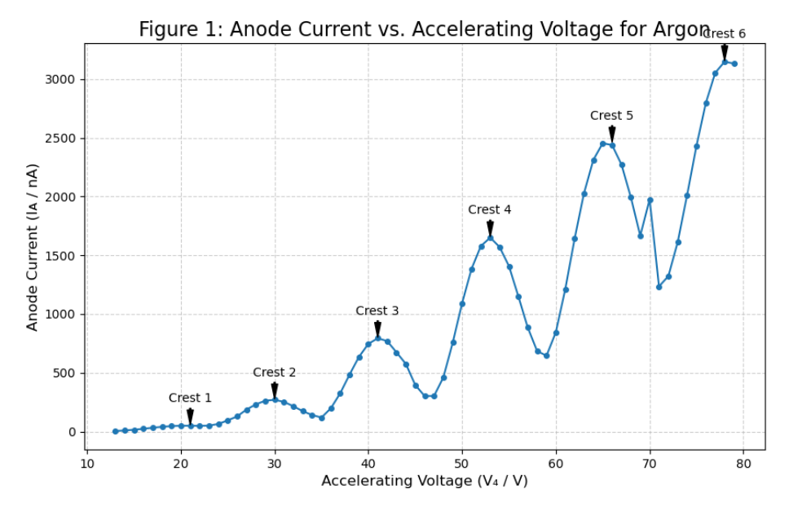

|  |
| --- |
| **Score** |
|  |

**Discussion** (More than 150 words, 5 points)

The experimental results offer a compelling validation of the quantum model of the atom. The measured value for the first excitation potential of argon was determined to be 10.87 V. This finding shows a strong correlation with the accepted literature value of 11.6 V, yielding a reasonably small relative error of 6.3%. The periodic rise and fall of the anode current observed in the I-V curve is a direct manifestation of the core principle of this experiment: electrons lose energy in discrete packets through inelastic collisions, which is only possible if the atoms themselves can only absorb energy in quantized amounts. The successful observation of this phenomenon is the primary achievement of the experiment.

The 6.3% discrepancy between the experimental and accepted values can be attributed to several systematic and instrumental factors, rather than procedural error. A significant source of systematic error is the contact potential difference that exists between the different metallic materials of the cathode and the grids. This inherent potential can create a constant offset in the effective accelerating voltage, meaning the voltage read from the power supply does not perfectly represent the true kinetic energy of the electrons. Another contributing factor is the space charge effect, where the cloud of electrons emitted by the cathode repels subsequent electrons, slightly altering the potential distribution within the tube and shifting the precise locations of the current peaks. Furthermore, the limitations of the instrument's resolution constrain the accuracy of the measurements; the voltmeter's discrete intervals make it challenging to pinpoint the exact voltage of the current maxima, introducing a degree of uncertainty into the final result.

Despite these inherent experimental limitations, the close agreement achieved provides a definitive and robust confirmation of the quantization of atomic energy levels.

|  |
| --- |
| **Score** |
|  |

**Conclusions** (About 50 words, 2 points)

This experiment successfully determined the first excitation potential of the argon atom to be 10.87 V, which corresponds to a relative error of 6.3% against the accepted value. This result accurately and directly confirms Bohr's theory of quantized atomic energy levels, thereby achieving the primary objective of the experiment.

|  |
| --- |
| **Score** |
|  |

**References** (1 points)

|  |
| --- |
| **Score** |
|  |

**Answers to Questions** (6 points)

(1) Different parameters of V₁, V₂, V₃, V₄ can be used in the experiment. How do the voltages affect the first excitation potential of argon atom and why?

The first excitation potential of an argon atom is an intrinsic, quantum property of the atom itself. It is a fixed physical constant (approximately 11.6 eV) and is not affected by the voltage parameters (V₁, V₂, V₃, V₄) used in the experiment.

However, these external voltages are crucial for the measurement of this potential. They affect the quality and clarity of the data, which in turn affects the accuracy of the determined value:

Filament Voltage (typically V₁): This voltage heats the cathode, causing thermionic emission of electrons. A higher V₁ increases the temperature, leading to a much larger electron current. This makes the signal stronger, but if it's too high, it can create a "space charge" effect that interferes with the measurement or even burn out the filament. It affects the magnitude of the anode current but not the spacing of the peaks.

Accelerating Voltage (typically V₂ or V₄ in your graph's case): This is the independent variable being swept. It provides kinetic energy to the electrons. The purpose of sweeping this voltage is to reveal the excitation potential, not to change it.

Retarding Voltage (typically V₃): This is a small negative voltage applied between the second grid and the anode. Its purpose is to repel electrons that have lost most of their energy in an inelastic collision. This greatly increases the contrast of the dips in the current, making the peaks much sharper and easier to measure accurately. The choice of V₃ is a trade-off: too small, and the dips are shallow; too large, and the overall current signal becomes too weak.

In summary, the voltages do not change the atom's excitation potential, but they critically affect our ability to measure it accurately by optimizing the signal-to-noise ratio and the resolution of the peaks.

(2) What's the most important conclusion for the Franck-Hertz experiment?

The most important conclusion of the Franck-Hertz experiment is that it provided the first direct, non-spectroscopic experimental evidence for the quantization of atomic energy levels.

Before this experiment, the Bohr model had postulated discrete energy states, but the primary evidence came from atomic spectra. This experiment demonstrated that atoms can only absorb energy from colliding electrons in specific, discrete amounts (quanta). The periodic drops in the anode current occur precisely at voltages where the electrons have just enough kinetic energy to transfer a fixed amount to an argon atom, exciting it to its first discrete energy state.

(3) What happens to the excited atoms? If radiation is involved, what is its wavelength and how could it be detected?

An excited atom is unstable and will quickly return to its ground state. To do so, it releases the energy it absorbed during the inelastic collision. This energy is emitted in the form of a photon of electromagnetic radiation.

The wavelength (λ) of this radiation can be calculated using the energy of the transition (E) and the Planck-Einstein relation (E=hc/λ). The energy E is equal to the first excitation potential, approximately 11.6 eV.

First, convert the energy from electron-volts (eV) to Joules (J):

E=11.6eV×(1.602×10−19J/eV)=1.858×10−18J

Now, calculate the wavelength:

λ=Ehc​=1.858×10−18J(6.626×10−34J⋅s)(3.00×108m/s)​≈1.07×10−7m=107 nm

This wavelength of 107 nm falls within the ultraviolet (UV) region of the electromagnetic spectrum.

Because it is outside the visible spectrum, this radiation cannot be seen with the naked eye. It could be detected using a specialized instrument like a UV spectrometer, which uses a diffraction grating to separate the light by wavelength and a UV-sensitive detector (like a photomultiplier tube or a specialized CCD) to measure its intensity.

(4) From the Data Tables 3.10-1, 3.10-2, and 3.10-3, how does the voltage V₁ affect the current through the picoammeter and why?

The voltage V₁ is the filament heating voltage. Based on the principle of thermionic emission, increasing the voltage V₁ will cause a significant (typically exponential) increase in the current measured by the picoammeter.

Why: The voltage V₁ controls the power dissipated by the filament, which determines its temperature. According to the Richardson-Dushman equation for thermionic emission, the number of electrons emitted per unit time from a hot cathode is highly dependent on its temperature. A higher temperature provides more thermal energy to the electrons in the metal, allowing more of them to overcome the material's work function and escape into the vacuum.

Therefore, as V₁ increases:

1.The filament gets hotter.

2.The rate of thermionic emission increases exponentially.

3.More electrons are available to be accelerated towards the anode.

4.This results in a larger overall anode current measured by the picoammeter.

Appendix

|  |
| --- |
| **Score** |
|  |

**(Calculations, 15 points)**

Compute the first excitation potential, *U*0, from the graph.

1. Choose one trace and read the horizontal coordinates of the crests. Put the voltages in the following table.

|  |  |  |  |  |  |  |
| --- | --- | --- | --- | --- | --- | --- |
| Crest | 1 | 2 | 3 | 4 | 5 | 6 |
| Voltages, *U* (V) | 21 | 30 | 41 | 53 | 66 | 78 |

1. Compute the difference of the voltages

U01=U2–U1=30V–21V=9V;

U02 =U3–U1=41V-21V=20V;

U03=U4–U1=53V-21V=32V;

U04=U5–U1=66V-21V=45V;

U05=U6–U1=78V-21V=57V;

1. Compute to the first excitation potential *U*0.

V

≈10.87V

1. The accepted value of the first excitation potential of argon is 11.6 V. Compute the relative error of you measurement.

The relative error was computed using the accepted value of 11.6 V for the first excitation potential of argon.

Formula: Relative Error= ​×100%

Substitution: Relative Error= ​×100%= ×100%

Result: Relative Error ≈ 6.3%

Appendix

**(Scanned data sheets)**

